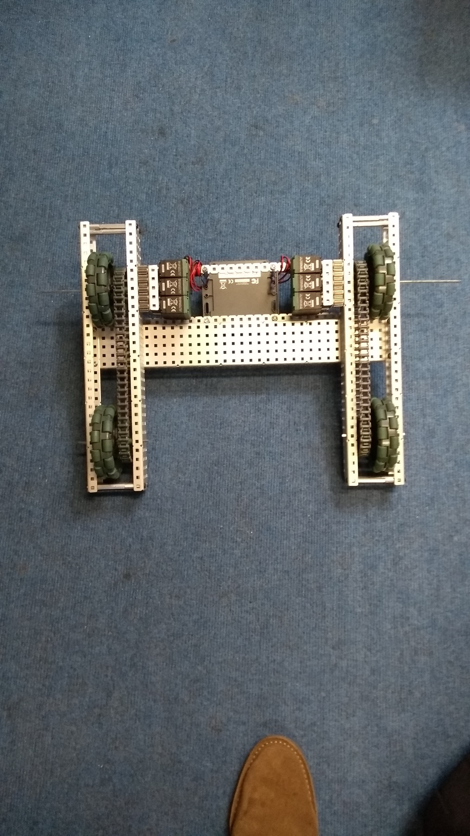

**Overview:**

This is only as small change to the prior version of the robot. None of the internal mechanism have been changed as the focus of this version was to modify the base to have a strong but light structure. Each of the wheel sections are now independently held together by stand-offs meaning that access to the wheel areas for modification of the mechanisms or structure is easier. The temporary structs on each end of the robot have also been replaced with a single bar across the middle allowing the base to be able to intake objects in the front without them being caught.

Logged by Robbie Buxton

21/06/2017 – 16:38

**Future Changes:**

* A battery mount needs to be built, with the ability to swap out charged and uncharged batteries with ease
* The mounting plate on the top needs to be added

**Changes Made:**

* The method that the chassis is held together by has been changed
* Basis for mounting plate added
* Shaft collars added to lock wheels into the robot

**Specification:**

* 6 Motor HS drive
* 2 drive chains
* 4 wheels
* Aluminium structure

**Dimensions:**

17.5” x 15”

Robot v1.1.1